cnc_wrzofs

声明
/* write work zero offset value */
[DllImport("FWLIB32.dll", EntryPoint = "cnc_wrzofs")]
public static extern short cnc_wrzofs(ushort FlibHndl, short a, [In, MarshalAs(UnmanagedType.LPStruct)] IODBZOFS b);

描述
写工件坐标偏移。

参数
（1）FlibHndl 库句柄；[ in ]
（2）length 设置长度；[ in ]
（3）zofsr； [ in ]
/* cnc_rdzofs:read work zero offset value */
/* cnc_wrzofs:write work zero offset value */
[StructLayout(LayoutKind.Sequential, Pack = 4)]
public class IODBZOFS
{
public short datano; /* offset NO. */
public short type; /* axis number */
[MarshalAs(UnmanagedType.ByValArray, SizeConst = MAX_AXIS)]
public int[] data = new int[MAX_AXIS]; /* data value */
}

函数返回值
函数运行正常返回EW_OK。
Return code | Meaning/Error handling
EW_LENGTH  (2) | Data block length error  Size of IODBZOFS structure(length) is wrong.
EW_NUMBER  (3) | Data number error  Offset number(datano) is wrong.
EW_ATTRIB  (4) | Data attribute error  Axis number(type) is wrong.
EW_DATA  (5) | Data error (Series 15, 30i, 0i-D)  Offset data(data) is out of range.
EW_NOOPT  (6) | No option (Series 16/18/21, 16i/18i/21i, 0i, 30i)  This function needs the work zero offset option.

代码
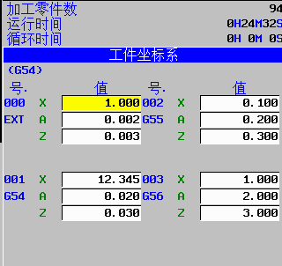
class Program
{
static void Main(string[] args)
{
ushort Flibhndl = 0;

short ret; // 返回值

// 获取库句柄 ( Ethernet )
ret = Focas1.cnc_allclibhndl3("192.168.0.224", 8193, 10, out Flibhndl);
if (ret != Focas1.EW_OK)
{
Console.WriteLine("发生异常，请检查！");
return;
}

#region cnc_wrzofs

short length = 100;
Focas1.IODBZOFS zofs = new Focas1.IODBZOFS();
zofs.datano = 1;
zofs.type = 1;
double _data = 12.345;
int data = int.Parse((_data * 1000).ToString());
zofs.data[0] = data;
ret = Focas1.cnc_wrzofs(Flibhndl, length, zofs);//写入1.2345
#endregion
}
}

